PPDBillet Pit Boss

Congratulations on the purchase of your PPD Pit Boss workstation, tweak plate, RC stand, and benchtop organizer!

Your precision machined workstation (upper and lower plates) is made of high quality certified 6061 T6 aluminum, and is built to last a lifetime of trouble free use with basic care. Please read care section for tips on cleaning and keeping its bright finish.

PLEASE NOTE. If removing the 6 top and bottom screws for extended travel—DO NOT OVERTIGHTEN the 4mm screws. All that is required is to snug down to touch then 1/8 turn. Over tightening can strip threads.

Recommended tools

- (Optional) Feeler gage set or min. .005, .010 and .020 feeler gages.

Tips on using

- Check bottom of chassis for high spots! Any high spot will distort the chassis once clamped, and will give undesirable results.
- Set the chassis onto plate with bumper toward “FRONT” engraved on plate, check the chassis before clamping by pressing down with 1 finger in different spots. This will tell you how far it is out. We recommend a feeler gage set for this, to get real numbers.
- Loosen all bulkhead and top deck screws and check again. With everything loose your chassis should be flat, if not that is likely the main problem. You can attempt to bring it back in but should consider replacement. Do not get concerned with ends of chassis (those often bow up but do not hurt performance), just try keep under .020 at the arm mount areas of chassis, less is surely better.
- Clamp chassis down at 4 cutout areas on plate (see sketch). There is no need to over tighten! Just a 3 finger snug will flatten the chassis.
- Starting with bulkheads cross tighten all screws to snug using a criss cross pattern. Go back through and tighten to spec tightness, repeat process on top deck.
- Now release clamps and check areas again, improvement should be made. If chassis is badly out again, loosen the areas around the problem spot, if it gets better there could be a bent screw, improper hole location, or possibly a bent bulkhead. The plate will lead you to the problem area, now you need use process of elimination to resolve.
- The tweak plate will remove as much twist from your chassis as possible…however, it does not fix bent bulkheads and badly warped chassis, you now have the tool to check that and quickly locate the problem. With the bulkhead and top deck screws 1 turn loose if chassis sits badly warped it likely wont come all the way back without replacement.

Care and cleaning

- Clean and remove light scratches with good quality liquid auto polish or metal polish such as Mothers billet polish. Use a extra fine scotch bright pad to remove light scratches. Deeper scratches can be removed with fine emery paper or very carefully flat filed off, just remember…NO HIGH SPOTS.
- Avoid harsh cleaners such as Simple Green, they can stain raw aluminum. For quick clean use spray auto detailer or soapy water, dry immediately.
- Armor All can be used to brighten up the plastic risers drawers and optional top cover. If top cover looses is cling effect to plate, Armor All will revive it.
- Do not expose to extreme heat or cold temperatures, and avoid sudden changes in temperature such as heat gun to a cold plate. Plate flatness is within +/-.005” and extreme temperatures can potentially warp. Your plate is a precision tool and needs to be treated as such.

Check back for accessories and more options at www.ppdbillet.com ®

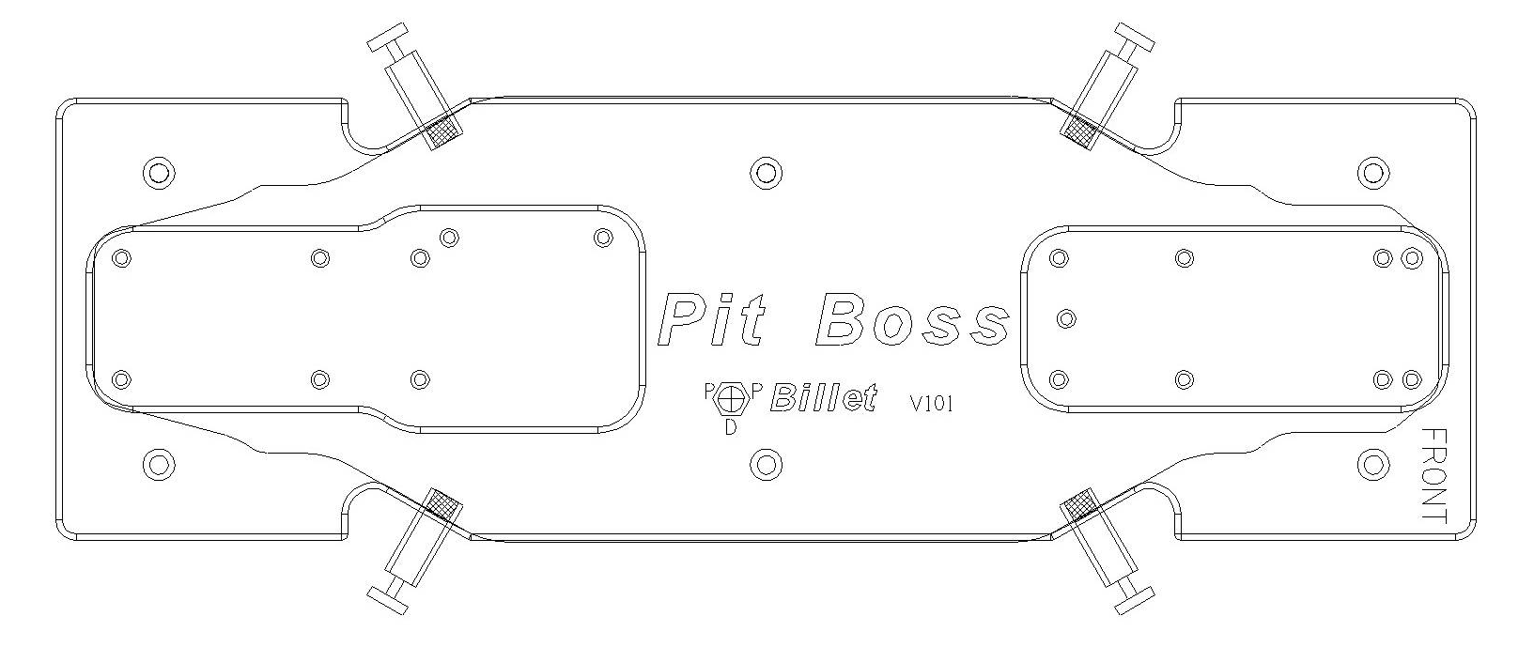

Approximate clamp locations

